Virtual Museum

by

Patrick Asata, , Akinseyi Famoyegun, , James Davidson

Dr. Sharad Sharma

Goals and Objectives:

The objective of our project was to create a virtual museum which contains two exhibits. The first exhibit will display a prehistoric era consisting in dinosaurs in a natural habitat. The second exhibit displays our solar system including the sun and the nine planets( we still consider pluto to be a planet) . Each exhibit will also contain information about the environments.

Modeling:

Modeling for the area of the virtual museum consisted of an outdoor environment. It included grass, trees, a paved road, and the museum itself(which is a three story building model we found from a third party source). The area of the virtual museum also has to camera views that show the outside surroundings of the museum and its entrance. The entrance of the museum is linked to the lobby. Once inside, the lobby consists of two statue-like objects. Each leading to its respective exhibit if clicked on.

Modeling for the Jurassic exhibit consists of a small landscape containing various dinosaurs and will have texts containing information about them. This exhibit contains the grass, trees, mountains, and three dinosaurs.

Modeling for the solar system exhibit consists of nine planets and the sun. Each planet has its respective texture mapping for more realism. They will also rotate and revolve around the sun. The sun emit light onto the planets. The background will also consist of stars.

Lighting:

For the lighting outside the museum, we have used the daylight system which is found in 3D Studio Max 2008. Inside the lobby of the museum, various omni lights are floating around in random positions. The Jurassic exhibit also uses the daylight system mentioned earlier. Finally, for the solar the system, there are multiple omni lights placed around the sun to emit lighting from all angles around the sun onto the planets.

Interpolators:

1. There are two touch sensors on the door of the museum.

2. In the lobby, two spheres have touch sensors leading to the exhibits.

3. The Jurassic exhibit has three touch sensors , each dinosaur object in the exhibit will be fitted with a touch sensor.

4. The planets and sun in the solar system will also have their own respective touch sensors.

Content:

-Creating the of the Museum Exterior :

1.)We encountered several issues with exporting the background environment from 3DS MAX to VRML. To correct this issue we decided to encompass the entire area inside a textured cube consisting of clouds. The trees shown in the object we actually cloned from a single tree object. Originally the entire area was littered with tree objects but we decided that it was wasting space and time rendering objects the user would never see. So in the end the trees out we deleted/moved to be appealing to the users perspective while limiting the size of the environment.

-Creating the Lobby Area:

1.) This area gave us the least amount of trouble, the pedestal objects were created independently and imported as ".3ds" files after the room was created. One issue we ran into here was the animation timing. Since these objects were created with different animation keys we had to decide which animation to be the dominant speed. After trying both we decided that subjecting the "Dino Eye" floating animation to the speed of the "Earth Sphere" resulted in the best possible sync.

-Creating the data for the exhibits:

1.) We tried many approaches to display the educational data associated with the objects in the exhibit. Our best choice came to be writing our own HTML script and anchoring these WebPages to their respective objects inside the environments. We chose this method in lieu of linking directly to external WebPages for two reasons. The first being that we want to make sure our project is fully functional on an offline, the second, we wanted to be able to insert a link back to a particular exhibits ".wrl" file.

Images: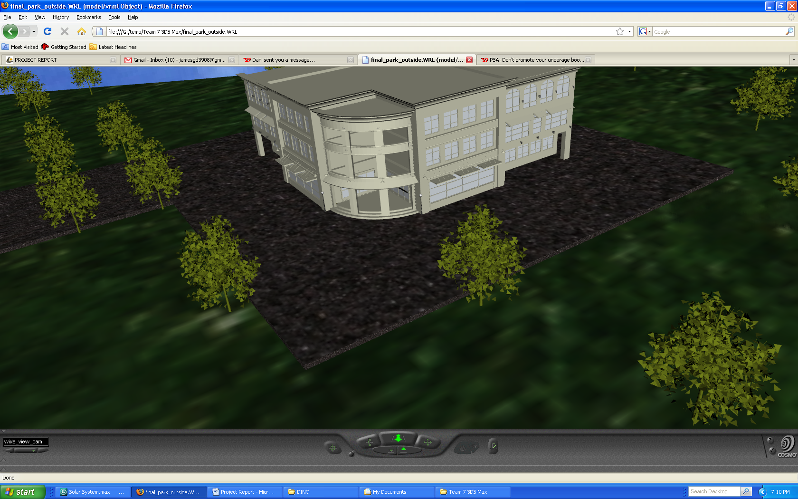

(This is a wide angle view of the outside of the museum) 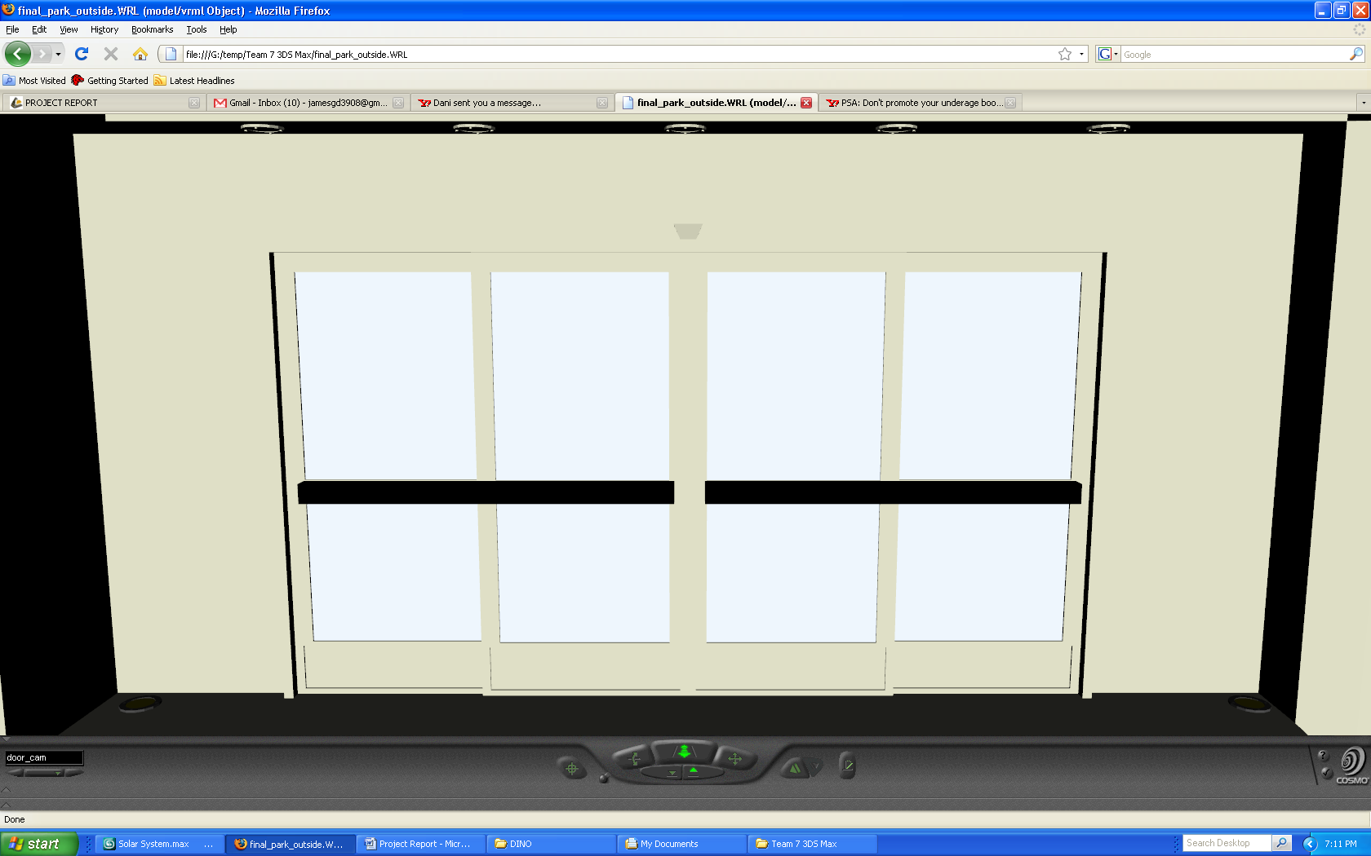

( This is a close up view of the entrance , the black bars are anchored to the lobby)

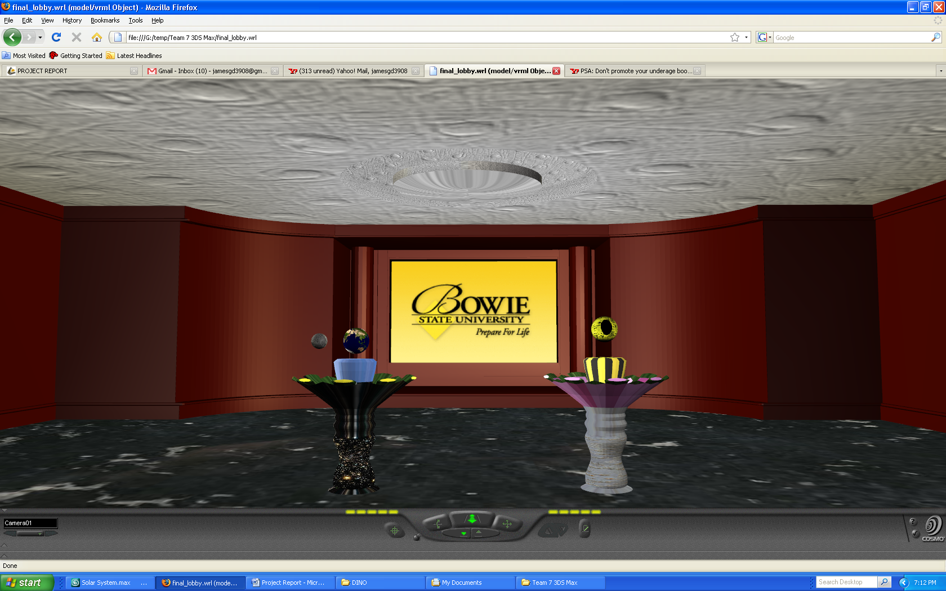

( This is the inside of the lobby , the orbs on the pedestals will take you to the two exhibits)

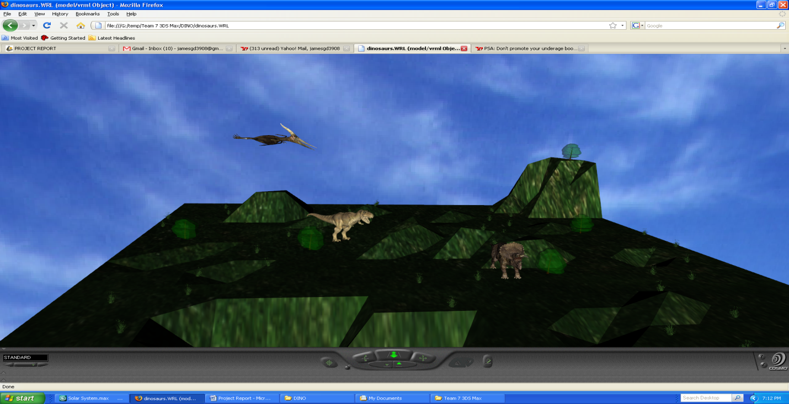

(This is a wide angle view of the dinosaur exhibit)

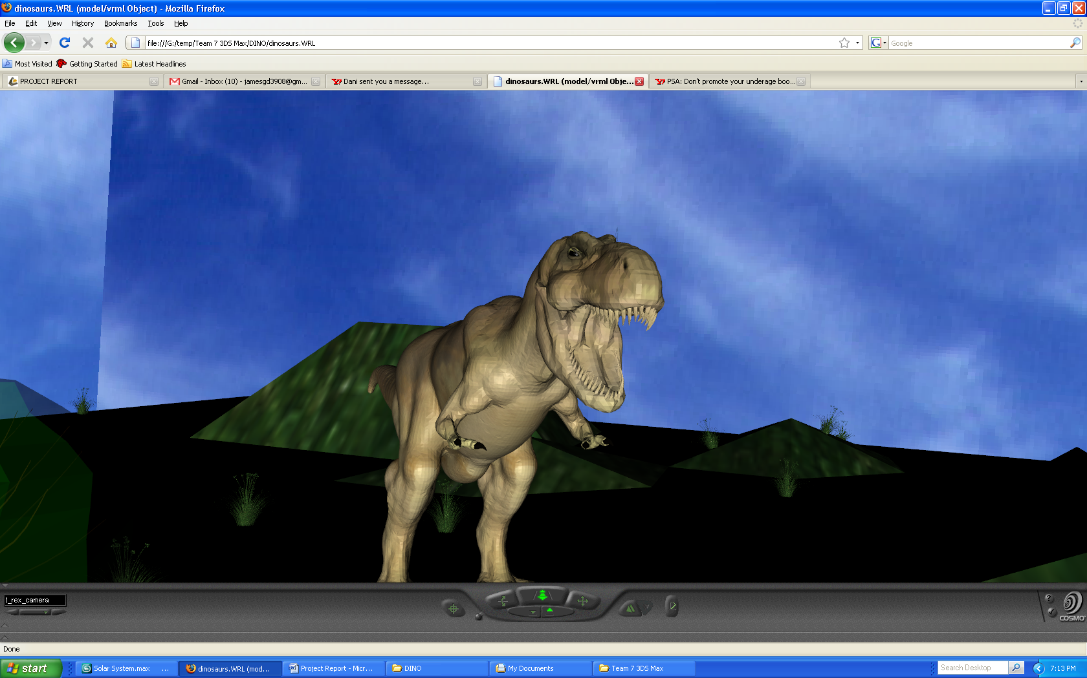

(This is a close up view of one of the dinosaurs , each will have their own viewport and anchor sending them to a link with more info)